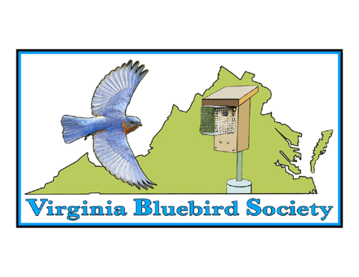
Our volunteers are the lifeblood of VBS. Our members' work is done away from the limelight, in the quiet company of nature. We realize that extra effort deserves recognition. That is why we've instituted awards to applaud the hard work put in by our members. We need your help in recognizing our dedicated volunteers. The awards will be given out at our bi-annual conference.
Here is a list of the awards:
Barbara Chambers Memorial County Coordinator of the Year - This award is given in memory of Barbara Chambers and the energy and inspiration she brought to bluebird conservation. A county coordinator's job is to collect the data for the county and pass it on to VBS. This award is given to a county coordinator who goes the extra mile to organize, inspire and further bluebird conservation in their county.
Bluebirder of the Year – This award is given to the individual who promotes bluebirds through outreach to schools and community groups, promoting good bluebird management techniques, and helping others to love and care for the bluebird.
Volunteer of the Year – This award is given to an individual who helps promote and enhance VBS. By giving of their time and energy, this individual helps VBS and the bluebird to grow and flourish in VA.
Vickie Fuquay Memorial Heritage Award - This award is not given every year by our organization. It recognizes an individual who has been a long time bluebirder. This is a special person who lives and breathes bluebirds and has spent many years promoting bluebirds and the love of bluebirds.
Please contact VBS Director Pam Narney at pnarney@gmail.com to nominate someone for an award. If you are not sure what category that person should be nominated for, just submit the name with some information and we will take it from there. Nominations must be in no later than September 1.

